**Introduction:**

Noise pollution monitoring is essential for understanding and mitigating environmental noise levels. In this project, we'll develop an IoT-based solution using a Raspberry Pi and a sound sensor to monitor noise pollution and store data in the cloud. We'll also create a Python script to manage data collection, processing, and visualization.

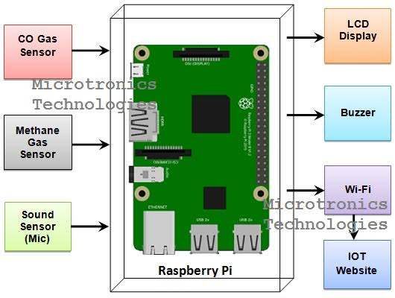

**python code:**

import os

import subprocess

import time

# Set up audio recording

audio_device = "hw:1,0" # Adjust based on your microphone

sample_rate = 44100

audio_duration = 10 # Duration of each recording in seconds

# IoT settings

iot_server = "your_iot_server_address"

iot_port = 1883

iot_topic = "noise_data"

while True:

# Record audio

audio_file = "temp_audio.wav"

command = f"arecord -D {audio_device} -r {sample_rate} -d {audio_duration} {audio_file}"

subprocess.call(command, shell=True)

# Process audio to calculate noise level (you'll need to implement this)

noise_level = process_audio(audio_file)

# Send data to IoT platform

iot_data = f"Noise Level: {noise_level} dB"

publish_data_to_iot(iot_server, iot_port, iot_topic, iot_data)

# Wait before the next recording

time.sleep(60) # Adjust as needed

**Hardware Components:**

**Noise Sensor**:

You'll need a noise sensor, like a microphone, that can capture audio data.

**Microcontroller**:

Use a microcontroller (e.g., Raspberry Pi, Arduino, ESP8266/ESP32) to interface with the noise sensor.

**Connectivity Module**:

Add a module (e.g., Wi-Fi, cellular, LoRa) for IoT communication.

**Power Supply**:

Ensure a reliable power source for your device.

**Enclosure**:

House the components in a protective enclosure suitable for outdoor use.

**Software Development**:

**Python script**:

Write a Python script to control the microcontroller and manage data.

2. **Data Collection**:

Set up the script to read data from the noise sensor.

3. **Data Processing**:

Process the raw audio data to calculate noise levels (in decibels, dB).

4. **Data Storage**:

Store the noise data locally or in the cloud. You can use databases like MySQL or cloud services like AWS, Google Cloud, or Azure.

5. **IoT Communication**:

Implement code for sending noise data to your chosen IoT platform.

6. **User Interface**:

Create a web dashboard or mobile app for users to monitor noise pollution levels